Subject

🔹 What is Subject
# Source: AI Source: Provided by: [Data Path: Persons Table -> ID Column: 1, Name_En Column: Motasem Essam] -> From: [Chatgpt (GPT-4-turbo)] on [8/3/2025]
The subject is the doer, theme, or topic of a sentence—it tells us who or what the sentence is about.
It usually performs the action of the verb or is the entity being described.

✅ Core Characteristics of the Subject:
# Source: AI Source: Provided by: [Data Path: Persons Table -> ID Column: 1, Name_En Column: Motasem Essam] -> From: [Chatgpt (GPT-4-turbo)] on [8/3/2025]
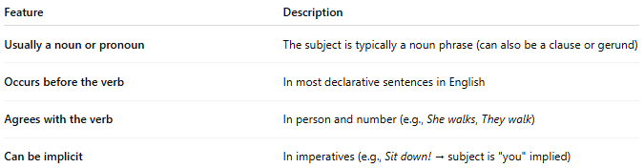
Feature | Description
Usually a noun or pronoun | The subject is typically a noun phrase (can also be a clause or gerund)
Occurs before the verb | In most declarative sentences in English
Agrees with the verb | In person and number (e.g., She walks, They walk)
Can be implicit | In imperatives (e.g., Sit down! → subject is "you" implied)

✅ Types of Subjects:
# Source: AI Source: Provided by: [Data Path: Persons Table -> ID Column: 1, Name_En Column: Motasem Essam] -> From: [Chatgpt (GPT-4-turbo)] on [8/3/2025]
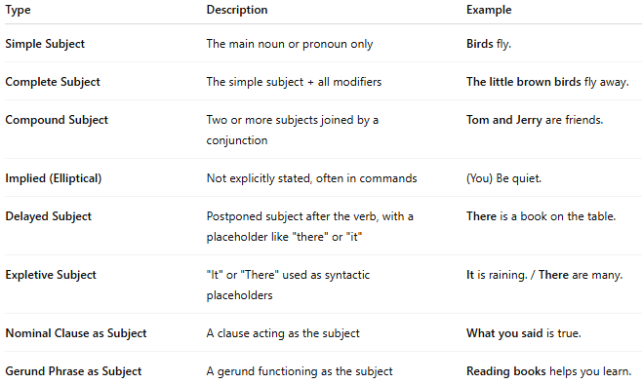
Type | Description | Example
Simple Subject | The main noun or pronoun only | Birds fly.
Complete Subject | The simple subject + all modifiers | The little brown birds fly away.
Compound Subject | Two or more subjects joined by a conjunction | Tom and Jerry are friends.
Implied (Elliptical) | Not explicitly stated, often in commands | (You) Be quiet.
Delayed Subject | Postponed subject after the verb, with a placeholder like "there" or "it" | There is a book on the table.
Expletive Subject | "It" or "There" used as syntactic placeholders | It is raining. / There are many.
Nominal Clause as Subject | A clause acting as the subject | What you said is true.
Gerund Phrase as Subject | A gerund functioning as the subject | Reading books helps you learn.

✅ Subject in Sentence Structure:
# Source: AI Source: Provided by: [Data Path: Persons Table -> ID Column: 1, Name_En Column: Motasem Essam] -> From: [Chatgpt (GPT-4-turbo)] on [8/3/2025]
In a basic sentence, the subject fits into this pattern:
Subject + Predicate
🔹 Example:
- The cat slept.
- Running fast helps.
- It is late.

✅ Subject-Verb Agreement Examples:
# Source: AI Source: Provided by: [Data Path: Persons Table -> ID Column: 1, Name_En Column: Motasem Essam] -> From: [Chatgpt (GPT-4-turbo)] on [8/3/2025]
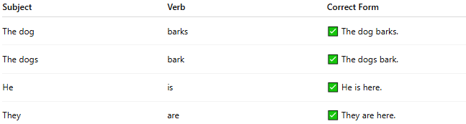
Subject | Verb | Correct Form
The dog | barks | ✅ The dog barks.
The dogs | bark | ✅ The dogs bark.
He | is | ✅ He is here.
They | are | ✅ They are here.

✅ Subject vs. Other Functions:
# Source: AI Source: Provided by: [Data Path: Persons Table -> ID Column: 1, Name_En Column: Motasem Essam] -> From: [Chatgpt (GPT-4-turbo)] on [8/3/2025]
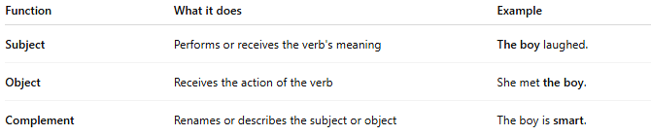
Function | What it does | Example
Subject | Performs or receives the verb's meaning | The boy laughed.
Object | Receives the action of the verb | She met the boy.
Complement | Renames or describes the subject or object | The boy is smart.

📝 Summary:
# Source: AI Source: Provided by: [Data Path: Persons Table -> ID Column: 1, Name_En Column: Motasem Essam] -> From: [Chatgpt (GPT-4-turbo)] on [8/3/2025]
- The subject is the core grammatical function indicating the agent or topic of the sentence.
- It can be simple, complete, compound, or implied.
- Subjects may be nouns, pronouns, gerunds, or even clauses.
- Understanding subject types is key for correct verb agreement, clause structure, and sentence clarity.

